Catalogue
Mosaics
Church of the Holy Cross

This part of the Catalogue identifies, by section, the mosaic icons thus far installed in the Church of the Holy Cross

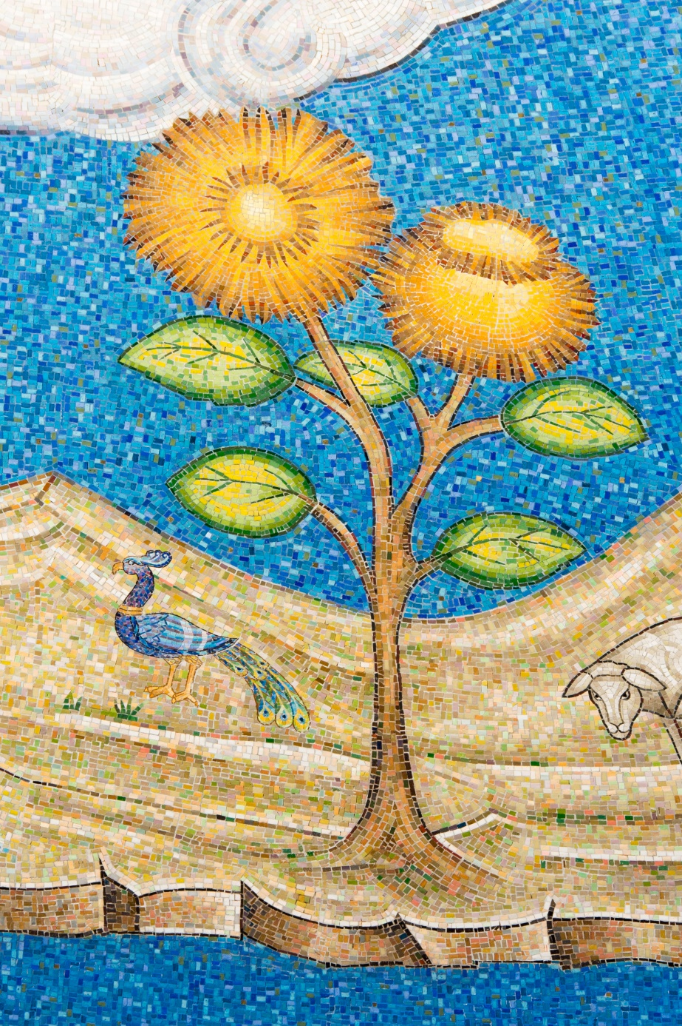
Printed For
Parishioners of the Church of the Holy Cross
under the supervision of
the Office of the Church of the Holy Cross.

PRESENTATION COPY.

January, 2017 Office of the Church

C A T A L O G U E

of

ICONS
AND OTHER CHURCH DECORATIONS

CHURCH OF THE HOLY CROSS BELMONT, CA
PRINTED FOR THE USE OF
THE MEMBERS OF
THE CHURCH OF THE HOLY CROSS

2017

FLOORPLAN VIEW

THE ALTAR
APSE
- THE COMMUNION OF THE APOSTLES, 200
- THE PLATYTERA, 200
- THE YELLOW ANGEL
- THE GREEN ANGEL
- THE ASCENDING ANGELS, NORTH
- THE ASCENDING ANGELS, SOUTH
- ANGELS HOLDING CROSS MEDALLION
- THE PHILOXENIA OF ABRAHAM
- LARGE CROSS MEDALLION, NORTH
- LARGE CROSS MEDALLION, SOUTH
- SERAPHIM, NORTH
- SERAPHIM, SOUTH
- MOTHER OF GOD, MEDALLIONS
- ALPHA MEDALLION
- OMEGA MEDALLION

HIERARCHS
North
- SAINT NIKOLAI VELIMIROVICH
- SAINT IRENAEUS, BISHOP OF LYONS
- SAINT GREGORY THE THEOLOGIAN
- SAINT ATHANASIOS OF ALEXANDRIA

South
- SAINT GREGORY PALAMAS, ARCHBISHOP OF THESSALONIKA
- SAINT GREGORY OF NYSSA
- SAINT CYRIL OF JERUSALEM
- SAINT IGNATIOS OF ANTIOCH

MEDALLIONS

- SAINT CHRISTINA
- SAINT NONA
- SAINT SERGIOS
- SAINT MENAS
- SAINT ANDREW
- SAINT BARBARA
- SAINT EUSTRATIOS
- SAINT ALEXANDRA
- SAINT MAKRINA
- SAINT IRENE
- SAINT PHANOURIOS
- SAINT ALEXANDER
- CROSS

NORTH WALL

- SAINT PROCHOROS. THE DEACON
- SAINT JOHN CHRYSOSTOM, WITH SCROLL
- NATIVITY, PROTHESIS

SOUTH WALL
- SAINT ROMANOS THE MELODIST
- SAINT BASIL THE GREAT, WITH SCROLL
- THE EXTREME HUMILITY OF CHRIST

THE ICON SCREEN

FULL LENGTH

- SAINT JOHN CHRYSOSTOM
- ARCHANGEL MICHAEL
- THE EXALTATION OF THE HOLY CROSS
- THE PANAYIA
- JESUS CHRIST
- SAINT JOHN THE BAPTIST
- ARCHANGEL GABRIEL
- SAINT KATHERINE THE GREAT

UPPER LEVEL
Disciples
- SAINT JAMES, SON OF ZEBEDEE
- SAINT JOHN, SON OF ZEBEDEE
- SAINT SIMON
- SAINT PETER
- SAINT THADDEUS
- SAINT THOMAS
- THE MYSTICAL SUPPER
- SAINT BARTHOLOMEW
- SAINT PAUL, THE APOSTLE
- SAINT JAMES, SON OF ALPHAEUS
- SAINT PHILIP
- SAINT MATTHEW
- SAINT ANDREW

GATES
Medallions
- MAN
- LION
- OX
- EAGLE
- ANGEL
- ANGEL

SOLEA
- THE CRUCIFIXION
- PULPIT
- BAPTISMAL FONT
- DOUBLE HEADED EAGLE
- THE DESCENT INTO HADES
- PSALTIRI
- BISHOPS THRONE
- MOVEABLE TABLE

PENDENTIVE SURFACES
FRONT LEFT
- SAINT MATTHEW THE DISCIPLE AND EVANGELIST
- MAN
- SAINT KONSTANTINE, THE EMPEROR
- SAINT THEODORA, THE EMPRESS

LIGHT FIXTURE, SMALL MEDALLIONS

- SAINT ANTHONY THE GREAT
- SAINT THEODORE THE COMMANDER
- SAINT PHOTINI
- SAINT GEORGE, BISHOP OF MALLEON
- SAINT KALLIOPIE
- SAINT ANNA, MOTHER OF THE THEOTOKOS
- SAINT JAMES, BROTHER OF OUR LORD
- SAINT DEMETRIOS THE MYRRH STREAMING
- SAINT JOHN CHRYSOSTOM
FRONT RIGHT
- SAINT JOHN THE EVNAGELIST AND THEOLOGIAN
- EAGLE
- SAINT HELEN
- SAINT PANTELEIMON
LIGHT FIXTURE, SMALL MEDALLIONS
- SAINT ANNA THE PROPHETESS
- SAINT HARALAMBOS
- SAINT PATRICK
- SAINT MARY MAGDALENE
- SAINT PARASKEVE
- SAINT MOSES THE BLACK
- SAINT SOPHIA, THE MARTYR
- SAINT SPYRIDON THE WONDERWORKER
- SAINT STEPHEN, THE ARCHDEACON AND PROTOMARTYR

BACK LEFT
- SAINT MARK THE EVANGELIST
- LION
- SAINT NEKTARIOS
- SAINT JOHN CLIMACUS
LIGHT FIXTURE, SMALL MEDALLIONS
- SAINT STAMATIOS
- SAINT MARY OF EGYPT
- SAINT GEORGE THE NEW MARTYR
- SAINT GEORGE, BISHOP OF MYTILENE
- SAINT MARY OF EGYPT
- SAINT PAUL THE APOSTLE
- SAINT SAVAS THE SANCTIFIED
- SAINT PATAPIOS
- CROSS
- STAR
BACK RIGHT
- SAINT LUKE THE EVANGELIST
- OX
- SAINT NICHOLAS
- SAINT JOHN MAXIMOVICH, BISHOP OF SAN FRANCISCO

LIGHT FIXTURE, SMALL MEDALLIONS

- SAINT GEORGE THE GREAT MARTYR
- SAINT EPHRAIM THE NEW MARTYR
- SAINT EUPHROSYNOS THE COOK
- SAINT HOPE, THE MARTYR
- SAINT ANASTASIA, THE GREAT MARTYR
- STAR
- CROSS

THE DOME

- THE PANTOKRATOR
- PROPHET ZACHARIAH
- PROPHET JEREMIAH
- PROPHET JOB
- PROPHET ISAIAH
- PROPHET ELIJAH
- PROPHET EZEKIEL
- PROPHET MICAH
- PROPHET SAMUEL
- PROPHET MOSES
- PROPHET JONAH
- PROPHET HOSEA
- PROPHET JOEL
- PROPHET DAVID
- PROPHET NOAH
- PROPHET DANIEL
- PROPHET SOLOMON
- I AM THE A AND Ο SAYING
- PALM TREE

RIGHT WALL
APSE
- ASCENSION

MEDALLIONS

- SAINT SERAPHIM OF SAROV
- SAINT MAXIMOS THE CONFESSOR
- SAINT LEONIDAS, BISHOP OF ATHENS
- SAINT IRENE, THE GREAT MARTYR
- SAINT CHRISTOPHER
- SAINT CYRIL, PATRIARCH OF ALEXANDRIA
- SAINT MARINA, THE GREAT MARTYR
- PROPHET ZACHARIAH, FATHER OF SAINT JOHN THE BAPTIST
- SAINT NIKITAS, THE GREAT MARTYR
- SAINT EUPHEMIA, THE GREAT MARTYR
- SAIINT DIONYSIOS THE AREOPAGITE
- SAINT STYLIANOS
- CROSS
WALL, LEFT TO RIGHT
- WEDDING OF CANAAN
- CHRIST FEEDING OF THE MULTITUDES
- RAISING OF LAZARUS
- ENTRY INTO JERUSALEM

LEFT WALL
APSE
- TRANSFIGURATION
MEDALLIONS
- SAINT IGNATIOS THE NEW, PATRIARCH OF CONSTANTINOPLE
- SAINT PHOTIOS THE GREAT, PATRIARCH OF CONSTANTINOPLE
- SAINT TARASIOS, PATRIARCH OF CONSTANTINOPLE
- SAINT PAUL THE CONFESSOR, PATRIARCH OF CONSTANTINOPLE
- SAINT EUTYCHIOS, PATRIARCH OF CONSTANTINOPLE
- SAINT GREGORY V, PATRIARCH OF CONSTANTINOPLE
- SAINT NIKIFOROS, PATRIARCH OF CONSTANTINOPLE
- SAINT METROPHANES, PATRIARCH OF CONSTANTINOPLE
- SAINT NIFON, PATRIARCH OF CONSTANTINOPLE
- SAINT GENNADIOS, PATRIARCH OF CONSTANTINOPLE
- SAINT STACHYS, PATRIARCH OF CONSTANTINOPLE
- SAINT ELEFTHERIOS, BISHOP OF ILLYRICUM
- CROSS

WALL, LEFT TO RIGHT

- WEDDING OF CANAAN
- FEEDING OF THE MULTITUDES
- RAISING OF LAZARUS
- ENTRY INTO JERUSALEM

CHOIR
APSE
- PARADISE
- NOAH
- THE SACRIFICE OF ISAAC
- MOSES AND THE BURNING BUSH
- THREE YOUTHS IN THE FURNACE

MEDALLIONS

- SAINT EPHRAIM THE SYRIAN
- SAINT SOPHRONIOS OF JERUSALEM
- SAINT ANATOLIOS, PATRIARCH OF CONSTANTINOPLE
- SAINT ROMANOS THE MELODIST
- SAINT JOHN KOUKOUZELIS
- SAINT KOSMAS THE HYMNONGRAPHER
- SAINT JOSEPH THE HYMNOGRAPHER
- SAINT ANDREW OF CRETE
- SAINT KASSIANI
- SAINT THEOPHANES THE BRANDED
- SAINT THEODORE OF STUDITE
- SAINT JOHN OF DAMASCUS

RAIL
- SAINT KOSMAS THE HYMNOGRAPHER
- PROPHET MOSES THE GODSEER
- KOIMOISIS
- PROPHET AARON
- SAINT JOHN OF DAMSCUS
NAVE DOORS
- SAINT COSMAS
- SAINT DAMIEN

NARTHEX
- DEISIS

TIMELINE OF ICONOGRAPHY

